**CURL, NETSTAT AND POSTMAN COMMANDS**

**19pw13-Madhumitha.S**

**CURL:**

To execute CURL command from cmd for a specified URL:

URL : **http://127.0.0.1:9000/test.html**

Port : 9000

Description : performs a get request , returns content of test.html

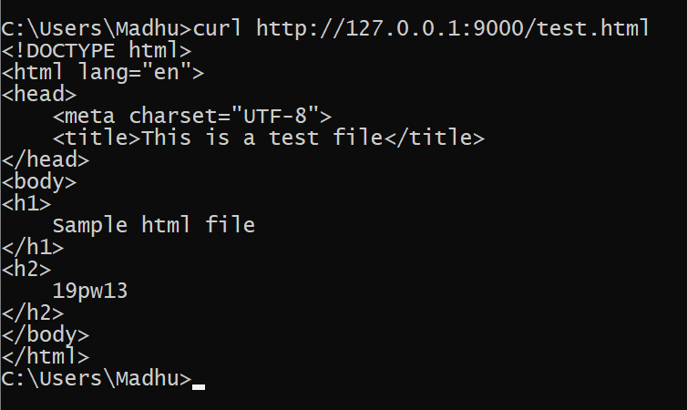

**NETCAT:**

**nc -z -v site.com**

This will run a basic [port scan](https://www.varonis.com/blog/port-scanning-techniques/) of the specified website or server. Netcat will return verbose results with lists of ports and statuses. One can use an IP address in place of the site domain.

The most basic syntax of the Netcat utility takes the following form:

**nc [options] host port**

By default, Netcat will attempt to start a TCP connection to the specified host and port. If you would like to establish a UDP connection, use the -u option:

**nc -u host port**

**POSTMAN:**

You can make requests to APIs in Postman. An API request allows you to retrieve data from a data source, or to send data. APIs run on web servers, and expose endpoints to support the operations client applications use to provide their functionality.

Each API request uses an HTTP method. The most common methods are GET, PUT, POST, DELETE

1. **GET** methods retrieve data from an API
2. **PUT** sends new data to an API.
3. **POST** method updates existing data.
4. **DELETE** removes existing data.

In Postman you can make API requests and examine the responses without using a terminal or writing any code. When you create a request and click **Send**, the API response appears inside the Postman user interface.